Machine Learning

1. Gradient Descent for Multiple Variables

1.1 Definition
Gradient Descent is an optimisation algorithm used in Machine Learning to minimise the cost function (error). When a problem has multiple input features, Multivariable Gradient Descent is used to find the best values of all parameters simultaneously.

1.2 Why Multiple Variables Are Needed
Real-world outcomes depend on more than one factor. House price depends on size, location, and number of bedrooms — not just one variable. A single-variable model is too simplistic to capture such relationships.

1.3 Single Variable vs Multiple Variable Regression
Aspect | Single Variable | Multiple Variable
Input features | 1 feature (x) | 2 or more features (x₁, x₂, …)
Hypothesis | h(x) = θ₀ + θ₁x | h(x) = θ₀ + θ₁x₁ + θ₂x₂ + …
Parameters | θ₀, θ₁ | θ₀, θ₁, θ₂, …, θₙ
Complexity | Simple, one slope | More complex, multiple slopes
Use case | One input → one output | Multiple inputs → one output

1.4 Applications of Gradient Descent
- Linear Regression
- Logistic Regression
- Neural Networks
- Deep Learning

2. Linear Regression with Multiple Variables

2.1 Multiple Features
Multivariate Linear Regression uses more than one input feature to predict a single continuous output. Each feature contributes independently to the final prediction.

2.2 House Price Prediction Example
We predict house price using two input features:
- x₁ = House size (square feet)
- x₂ = Number of bedrooms
- y = House price (output / target)

2.3 The Multivariable Hypothesis Function

2.4 Term Definitions
Symbol | Name | Meaning
hθ(x) | Predicted value | The model output — what the model guesses
θ₀ | Bias / Intercept | Constant term; shifts the prediction line up or down
θ₁, θ₂ | Weights / Parameters | How strongly each feature influences the prediction
x₁ | Feature 1 | First input variable (e.g., house size)
x₂ | Feature 2 | Second input variable (e.g., number of bedrooms)

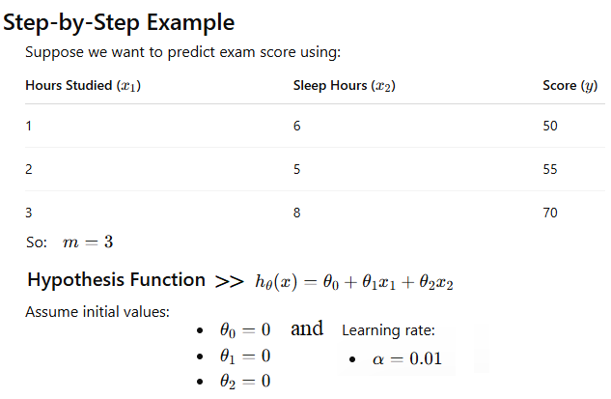
Figure 1 — Step-by-step example with two features (hours studied & sleep hours → exam score)

3. Hypothesis Function

3.1 General Form (n Features)

3.2 Components Explained

Features
Features are the input variables given to the model. Each feature represents one measurable property of a data point (e.g., house size, number of rooms, distance from city centre).
In vector notation, all features are collected as:
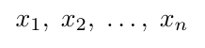

Weights / Parameters
Weights (also called parameters or coefficients) are numbers the model learns during training. A large weight means the corresponding feature has a strong influence on the prediction. All weights together are:
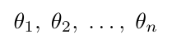

Bias Term θ₀
The bias term is an extra constant added to the equation. Without it, the hyperplane of predictions would always pass through the origin, which is almost never correct for real data. The bias shifts the prediction surface freely.
Memory rule: θ₀ is the y-intercept. θ₁, θ₂, … are the slopes for each feature. Together they define the prediction hyperplane.

4. Working Process — Step by Step

Gradient Descent for multiple variables follows these seven steps each iteration:
- Input Features — Feed training data with all features and true outputs y into the model.
- Prediction — Calculate the predicted output using the current hypothesis hθ(x).
- Error Calculation — Compute the residual for each example: (hθ(x) − y).
- Cost Function — Aggregate all errors into a single scalar J(θ) via Mean Squared Error.
- Gradient Calculation — Compute the partial derivative ∂J/∂θⱼ for each parameter.
- Parameter Update — Simultaneously update every θⱼ using the update rule.
- Iterate — Repeat steps 2 – 6 until J(θ) converges (stops decreasing meaningfully).

4.1 Cost Function
The cost function measures total prediction error over all m training examples:
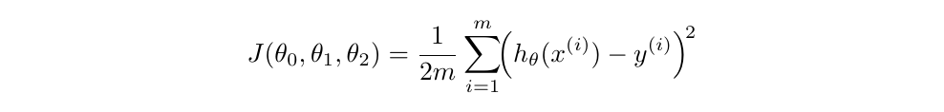
Symbol | Meaning
m | Number of training examples
y⁽ⁱ⁾ | Actual (true) output value for the i-th example
hθ(x⁽ⁱ⁾) | Predicted value for the i-th example
J(θ) | Scalar cost value — this is what we minimise

4.2 Gradient Descent Update Rule
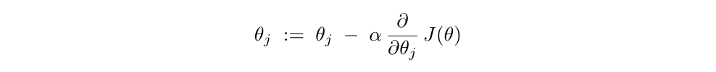
Substituting the partial derivative explicitly:
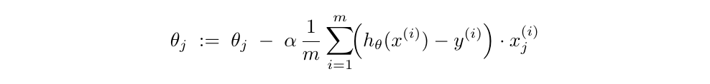
Repeat until convergence:
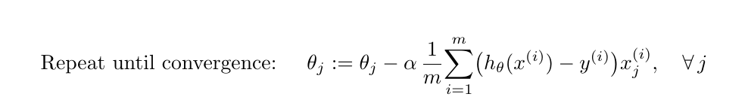

4.3 Numerical Worked Example
Using: Hours Studied (x₁), Sleep Hours (x₂) → Exam Score (y). Initial values: θ₀ = θ₁ = θ₂ = 0, learning rate α = 0.01.

Figure 2 — Dataset and initial hypothesis setup
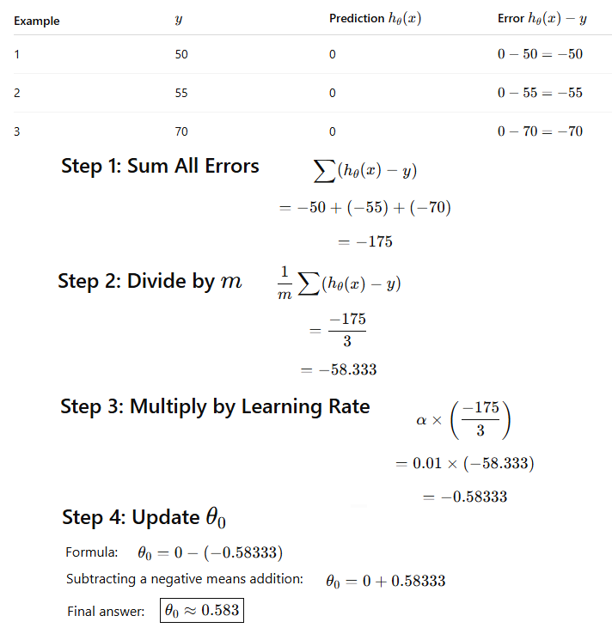
Figure 3 — Step-by-step calculation of the θ₀ update
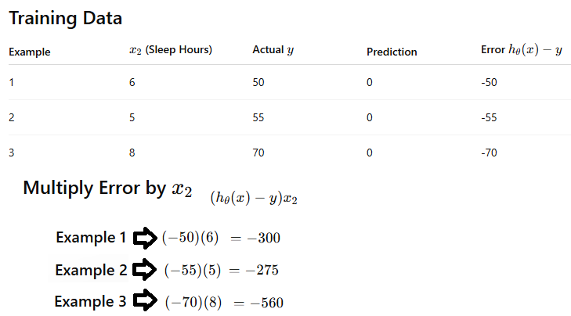
Figure 4 — Multiplying error by x₂ for the θ₂ update
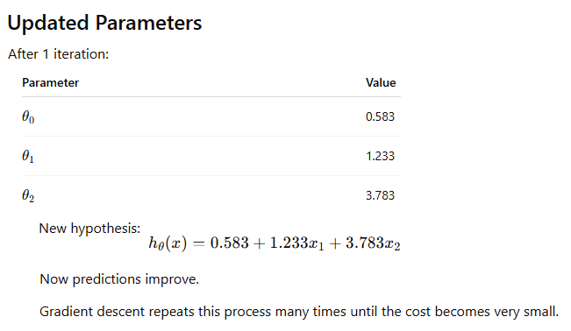
Figure 5 — Updated parameters after one complete iteration
After one iteration: θ₀ ≈ 0.583, θ₁ ≈ 1.233, θ₂ ≈ 3.783. The model continues iterating until the cost becomes negligibly small.

5. Gradient Descent Variants

Gradient Descent comes in three variants that differ only in how many training examples are used per parameter update. Choosing the right variant depends on dataset size, available memory, and desired convergence properties.
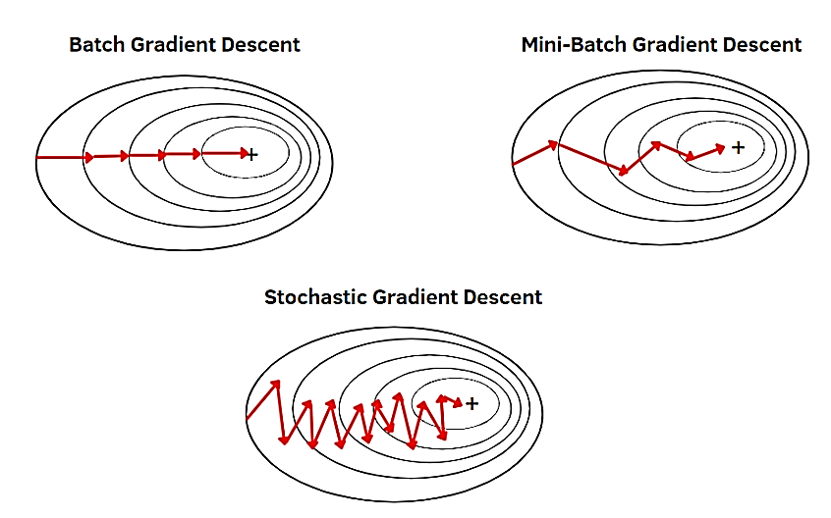
Figure 6 — Convergence paths: Batch (smooth) vs SGD (noisy) vs Mini-Batch (balanced)

5.1 Batch Gradient Descent

Definition
Batch GD computes the gradient of the cost function using the entire training dataset before making a single parameter update. One full pass over all data = one update.

Update Rule
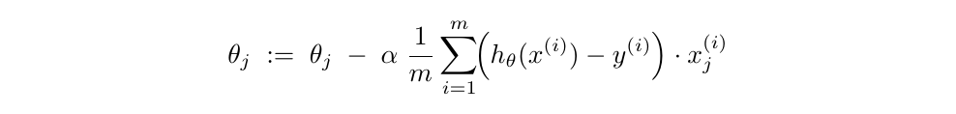

Working Process
- Load the entire training dataset into memory.
- Calculate the prediction and residual for every training example.
- Sum and average the gradients over all m examples.
- Update every parameter θⱼ once using the averaged gradient.
- Repeat until J(θ) converges.

Advantages
- Smooth, stable convergence path — predictable behaviour.
- Accurate parameter updates because every example contributes.
- Guaranteed convergence to the global minimum for convex cost functions.

Disadvantages
- Requires the entire dataset in RAM — infeasible for large datasets.
- Very slow — one parameter update per full data pass.
- Cannot support online learning (new data requires restarting).
- Can get stuck in saddle points in non-convex landscapes.

Real-World Example — House Price Prediction
With 10 000 house records, Batch GD reads all 10 000 before updating weights even once. Each iteration is slow, but every update is maximally informed.

Summary Table
Property | Batch GD
Data per update | All m training examples
Memory requirement | High — full dataset in RAM
Speed per epoch | Very slow
Convergence path | Smooth and direct
Online learning | Not supported
Best for | Small datasets

5.2 Stochastic Gradient Descent (SGD)

Definition
SGD updates the model parameters after processing just one randomly selected training example at a time. "Stochastic" refers to the random selection of that one example.

Update Rule
Notice: there is no summation, no average — one example drives the update.

Working Process
- Shuffle the training dataset.
- Pick one training example (x⁽ⁱ⁾, y⁽ⁱ⁾).
- Compute prediction, residual, and gradient for that single example.
- Immediately update all parameters θⱼ.
- Move to the next example and repeat.

Why SGD Is Faster
Batch GD makes 1 update per epoch; SGD makes m updates per epoch. Even though each update is less accurate, the model learns far more quickly overall.

Online Learning
SGD processes one example at a time, so new data can arrive continuously. This makes it ideal for real-time systems such as recommendation engines or stock-price predictors.

Escaping Local Minima
The noise in SGD updates can accidentally jump over shallow local minima, allowing the optimiser to find a better overall solution than Batch GD might.

Advantages
- Frequent updates — learns much faster than Batch GD.
- Minimal memory — only one example per step.
- Supports online learning and streaming data.
- Noisy updates can escape local minima.

Disadvantages
- High variance in updates — noisy, oscillating convergence path.
- Difficult to reach the exact minimum — oscillates around it.
- Requires careful tuning of learning rate α.

Real-World Example — Image Classification
Training a neural network on millions of images: loading all images at once is impossible. SGD processes one image at a time, continuously updating weights.

5.3 Mini-Batch Gradient Descent

Definition
Mini-Batch GD divides the dataset into small batches (typically 32 – 256 examples) and updates parameters after each batch. It is the most widely used variant in practice, including all major deep-learning frameworks.

Update Rule
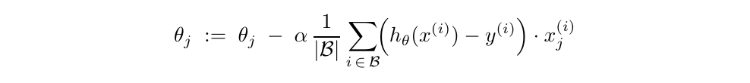
where ℬ is a mini-batch and |ℬ| is the batch size.

Working Process
- Divide the dataset into mini-batches of size |ℬ| (e.g., 32).
- For each mini-batch: compute predictions, residuals, and averaged gradient.
- Update all parameters θⱼ.
- Move to the next mini-batch until the full dataset is processed (= 1 epoch).
- Repeat for multiple epochs until convergence.

Why It Combines the Best of Both
- From Batch GD: more accurate, more stable updates than pure SGD.
- From SGD: memory-efficient, much faster than full Batch GD.
- From hardware: exploits GPU parallelism — multiple examples processed simultaneously.

Advantages
- Efficient GPU/CPU utilisation via batch matrix operations.
- Stable convergence — less noisy than SGD.
- No need to hold the entire dataset in RAM.
- Best generalisation performance in practice.

Disadvantages
- Requires tuning of the batch-size hyperparameter.
- Slightly less accurate per update than full Batch GD.
TensorFlow and PyTorch default to Mini-Batch GD. Typical batch sizes: 32, 64, 128, 256 — powers of 2 for GPU efficiency.

6. Comparison of Gradient Descent Algorithms

Property | Batch GD | SGD | Mini-Batch GD
Data per update | All m examples | 1 example | |ℬ| examples (32–256)
Speed | Slow | Fast (m updates/epoch) | Fastest in practice
Memory usage | High (full dataset) | Very low (1 sample) | Low to medium
Accuracy per update | High | Low (noisy) | Medium–high
Convergence path | Smooth, direct | Noisy, zigzag | Slightly noisy, stable
Stability | Very stable | Unstable / noisy | Stable
Escapes local minima | No | Yes (noise) | Partial
Online learning | No | Yes | Yes
GPU efficiency | Low | Low | High
Best dataset size | Small only | Large / streaming | All sizes
Common usage | Textbook examples | Real-time systems | Deep learning standard

7. Gradient Descent Update Rule

7.1 The Formula


7.2 Each Component Explained
Symbol | Name | Role in the Update
θⱼ | Parameter | The weight currently being updated
α | Learning rate | Controls the step size; chosen by the practitioner
∂J/∂θⱼ | Gradient | Direction of steepest increase of cost — we subtract it to descend
J(θ) | Cost function | Total prediction error to be minimised

7.3 The Partial Derivative (Gradient)
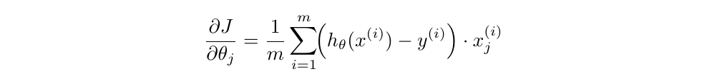

7.4 Intuition — Rolling Downhill
Imagine the cost function J(θ) as a hilly landscape. Gradient Descent is like placing a ball on a hill and letting it roll to the lowest valley:
- The gradient tells which direction is "uphill" (increasing cost).
- Subtracting the gradient moves "downhill" (decreasing cost).
- The learning rate α controls how large each step is.

7.5 Learning Rate Behaviour
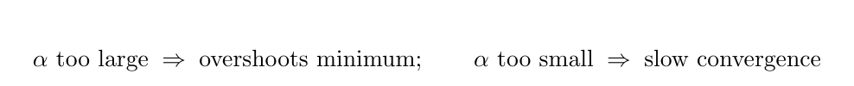
Learning Rate α | Effect | Outcome
Too large | Steps overshoot the minimum | Cost diverges (increases)
Too small | Steps are tiny | Very slow convergence
Just right | Steps are well-sized | Converges efficiently

Critical rule: ALL parameters θ₀, θ₁, θ₂, … must be updated simultaneously using the OLD values. Never use a freshly updated parameter in the same iteration.

8. Bias

8.1 Definition
Bias is the error that arises from wrong assumptions in the learning algorithm. A biased model oversimplifies reality and fails to capture the true underlying pattern in the data. It is defined as the difference between the expected prediction and the true value.
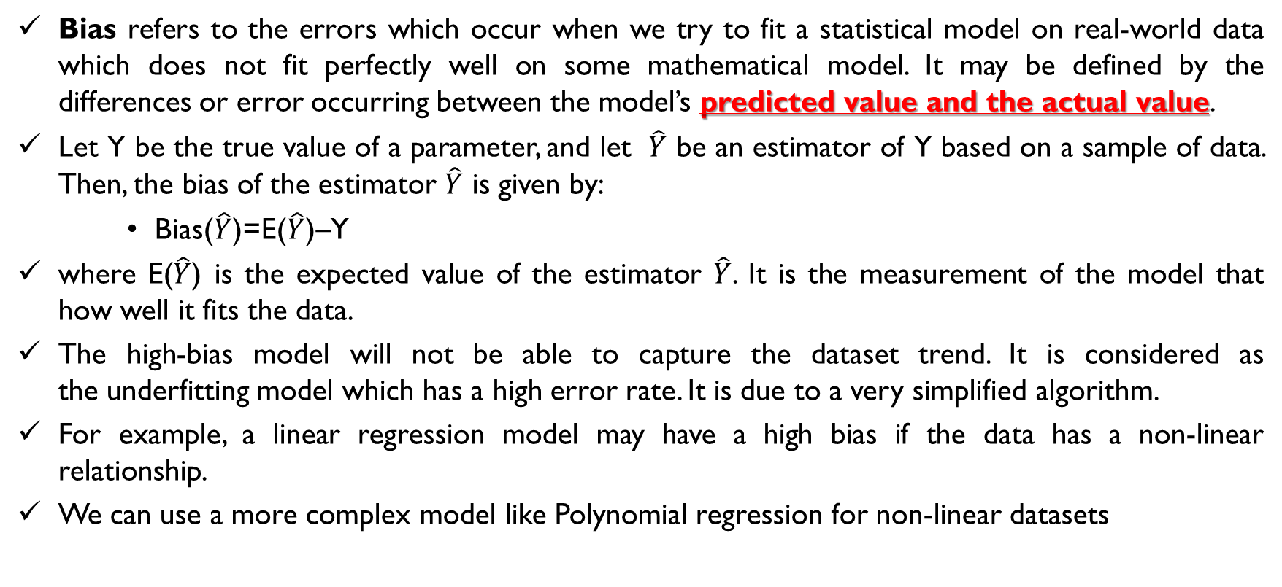
Figure 7 — Bias definition from lecture slides

8.2 Mathematical Definition
Symbol | Meaning
Ŷ (Y-hat) | The estimator / model's predicted value
𝔼[Ŷ] | Expected value of Ŷ — average prediction over many datasets
Y | The true actual value
Bias(Ŷ) | Systematic gap between expected prediction and truth

8.3 Formal Bias² Definition
Here f̂(x) is the model's prediction and f(x) is the true function.

8.4 High Bias
A model with high bias makes overly simple assumptions. It systematically underpredicts or overpredicts, regardless of the training data seen — this is called underfitting.

Example: Linear Regression on Non-Linear Data
If the true relationship is curved (polynomial) but we force a straight line, the model has high bias. No matter how much data we use, the line cannot capture the curve.
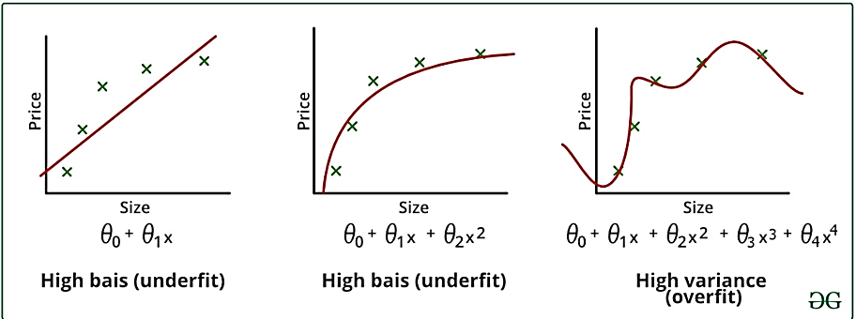
Figure 8 — High bias (underfit) vs high variance (overfit) illustrated on house price data

8.5 Characteristics of High-Bias Models
Characteristic | Description
Training error | High — the model misses even training patterns
Test error | High — poor generalisation to new data
Model complexity | Too low — e.g., linear model on curved data
Error type | Underfitting
Fix | Use a more complex model; add more features

9. Variance

9.1 Definition
Variance measures how much a model's predictions change when it is trained on different subsets of the training data. A high-variance model is overly sensitive to small fluctuations or noise in the training set.

9.2 Formal Definition

9.3 Sensitivity to Training Data
If you train the same model architecture on two slightly different training sets and obtain very different prediction curves, the model has high variance — it is memorising training data rather than learning the underlying pattern.

9.4 Why Variance Occurs
- Model is too complex (high-degree polynomial with many parameters).
- Model is trained on too little data.
- No regularisation is applied.
- Model captures noise in the training data as if it were a real signal.

9.5 High Variance = Overfitting
A high-variance model fits training data perfectly but fails on any unseen example. Training error is very low; test error is very high.

9.6 Characteristics of High-Variance Models
Characteristic | Description
Training error | Very low — fits every point
Test error | Very high — cannot generalise
Model complexity | Too high — wiggly, over-parameterised
Error type | Overfitting
Fix | Regularisation; more training data; simpler model

10. Bias vs Variance

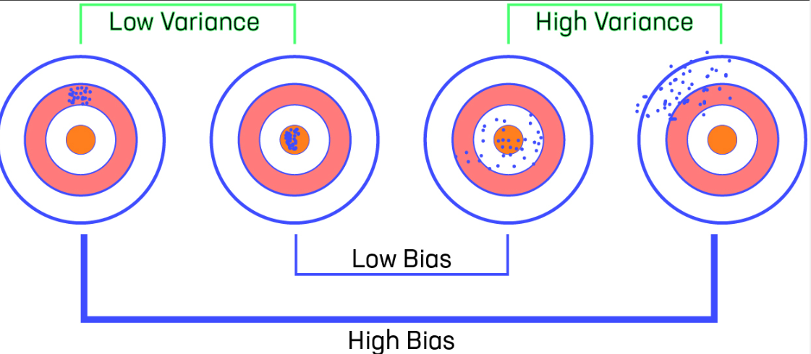
Figure 9 — Target diagram: Low/High Bias × Low/High Variance
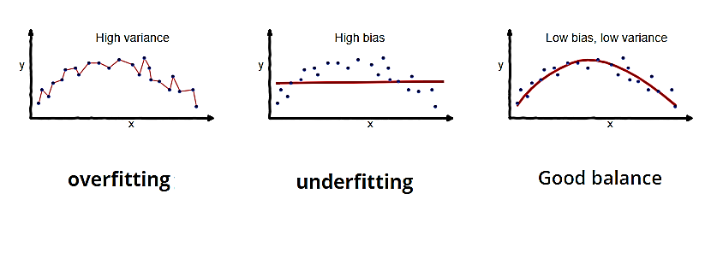
Figure 10 — Overfitting, Underfitting, and Good Balance

10.1 Key Definitions
Term | Definition
Low Bias | Average prediction is very close to the true value
High Bias | Predictions are consistently and systematically wrong
Low Variance | Predictions are tightly clustered — consistent across datasets
High Variance | Predictions are widely scattered — change a lot with different training sets

10.2 Why Both Matter
Both bias and variance are sources of prediction error. The ideal model has low error on unseen data, which requires both: accurate average predictions (low bias) and stable predictions regardless of the specific training set (low variance).

10.3 Model Complexity and the Tradeoff
As model complexity increases (more parameters, higher-degree polynomial): bias decreases but variance increases. As complexity decreases: bias increases but variance decreases. There is a sweet spot — the optimal model complexity.

11. Four Bias-Variance Cases

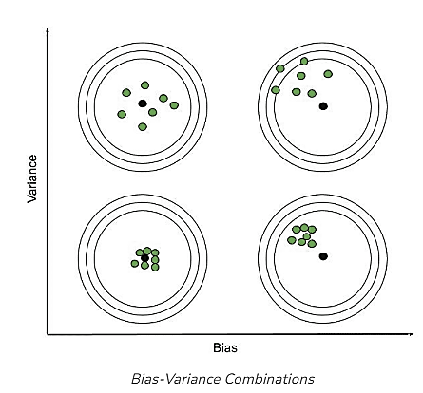
Figure 11 — All four bias-variance combinations on a target diagram

Case 1 — High Bias + Low Variance (Underfitting)
The model consistently predicts in the wrong direction but the predictions are tightly clustered. It is too simple to capture the real pattern.
- Training error: High
- Test error: High
- Problem: Underfitting — model is too simple.
- Fix: Use a more complex model or add more features.

Case 2 — Low Bias + High Variance (Overfitting)
The model memorises the training data and predicts it almost perfectly, but predictions on new data are scattered and unreliable.
- Training error: Very low
- Test error: Very high
- Problem: Overfitting — model is too complex.
- Fix: Regularisation; more training data; reduce model complexity.

Case 3 — High Bias + High Variance (Worst Case)
Predictions are both systematically wrong (high bias) and inconsistent (high variance). This is the worst possible model — it fails on both training and test data, and in different ways each time.
- Training error: High
- Test error: Very high
- Fix: Fundamental redesign of model and/or data preprocessing.

Case 4 — Low Bias + Low Variance (Ideal)
The ideal goal. Predictions are accurate on average (low bias) and consistent across different training datasets (low variance). The model generalises well to unseen data.
- Training error: Low
- Test error: Low and close to training error
In practice, perfectly achieving Low Bias + Low Variance is impossible. We use regularisation, cross-validation, and ensemble methods to get as close as possible.

12. Bias-Variance Tradeoff

12.1 Definition
The Bias-Variance Tradeoff is the fundamental tension between a model's ability to fit training data (low bias) and its ability to generalise to new data (low variance). Reducing one tends to increase the other.

12.2 Total Error Decomposition
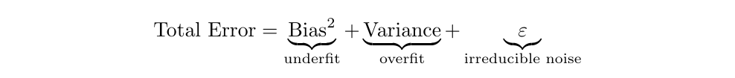
Irreducible noise (ε) is inherent randomness in any real-world dataset — it cannot be eliminated regardless of the model used. We can only minimise Bias² + Variance.

12.3 Why the Tradeoff Exists
A simple model (straight line) cannot capture complex patterns → high bias. A complex model (high-degree polynomial) fits every training point perfectly → high variance. There is no single model that is both perfectly accurate on average and perfectly stable.

12.4 Model Tuning Strategy
Symptom Observed | Root Cause | Recommended Fix
High training error + High test error | High Bias (Underfit) | More complex model; add features; reduce regularisation
Low training error + High test error | High Variance (Overfit) | Regularisation; more data; simpler model; dropout
High training error + Very high test error | High Bias + High Variance | Redesign model architecture; clean and augment data

12.5 Practical Importance
- Guides every modelling decision: model selection, feature engineering, regularisation.
- Cross-validation estimates whether the model suffers more from bias or variance.
- Regularisation is the most practical tool for managing the tradeoff.
Key insight: Regularisation deliberately introduces a small amount of bias in exchange for a much larger reduction in variance. The net effect is a better-performing model on unseen data.

13. Correlation

13.1 Definition
Correlation measures the statistical relationship between two variables. In machine learning, correlation analysis guides feature selection and reveals how strongly each feature relates to the target variable.

13.2 Types of Correlation
Type | Description | Plot Pattern | Example
Positive | Both variables increase together | Upward trend | Hours studied → Exam score
Negative | One increases, the other decreases | Downward trend | Sleep deprivation → Performance
Zero / None | No predictable relationship | Random scatter | Shoe size → Intelligence

13.3 Interpretation
Correlation does not imply causation. Two features may be highly correlated without either causing the other (e.g., ice-cream sales and drowning incidents both rise in summer — the real cause is temperature). In ML, correlated features can cause multicollinearity, making coefficient estimates unstable. Ridge Regression handles multicollinearity well.

14. Regularization

14.1 Definition
Regularisation is a technique that prevents overfitting by adding a penalty term to the cost function. This penalty discourages the model from assigning very large values to its parameters, thereby reducing model complexity.

14.2 Why Regularisation Is Needed
Overfitting occurs when a model is too complex — it memorises the training set and fails on new data. Regularisation controls this by penalising large parameter values, forcing the model to stay simple even if a complex equation form is used.

14.3 How It Works

Penalising Large Coefficients
Without regularisation the optimiser freely sets any parameter value. With regularisation large parameter values increase the total cost, so the optimiser is forced to keep them small.

Reducing Model Complexity
Smaller parameter values mean the model relies less on individual features. This reduces the tendency to fit noise rather than signal.

Improving Generalisation
A regularised model trades a small amount of training accuracy for much better test accuracy. This trade-off is almost always worthwhile.

14.4 Benefits of Regularisation
- Prevents overfitting.
- Improves performance on test / unseen data.
- Can implicitly perform feature selection (Lasso).
- Works well for high-dimensional data (many features).
- Produces more stable, reliable models.
- Helps achieve a better balance between bias and variance.

15. Min-Max Normalization

15.1 Definition
Min-Max Normalisation (also called feature scaling) transforms all values of a feature to a fixed range, typically [0, 1]. It ensures every feature contributes equally to the gradient regardless of its original scale.

15.2 Formula
Symbol | Meaning
x | Original feature value
x_min | Minimum value in that feature column
x_max | Maximum value in that feature column
x_norm | Scaled value in [0, 1]

15.3 Why Feature Scaling Is Needed
In Gradient Descent, if features have very different scales (e.g., house size in thousands vs number of rooms as single digits), the cost surface becomes elongated and narrow. The gradient takes tiny steps in one direction and huge steps in another, causing slow, oscillating convergence. Normalisation makes the cost surface more circular and convergence much faster.

15.4 Benefits
- Dramatically faster Gradient Descent convergence.
- Prevents large-scale features from dominating smaller ones.
- Required for algorithms sensitive to scale: KNN, SVM, Neural Networks.
- Improves numerical stability of the optimiser.

15.5 Worked Example
Original house sizes: [500, 1000, 1500, 2000] sq ft
x_min = 500, x_max = 2000
Normalised values:
- 500 → (500 − 500) / (2000 − 500) = 0.00
- 1000 → (1000 − 500) / (2000 − 500) = 0.33
- 1500 → (1500 − 500) / (2000 − 500) = 0.67
- 2000 → (2000 − 500) / (2000 − 500) = 1.00

16. Overfitting

16.1 Definition
Overfitting occurs when a model learns the training data too well — including noise and random fluctuations — and fails to perform on new, unseen data. The model memorises rather than generalises.

16.2 House Price Example
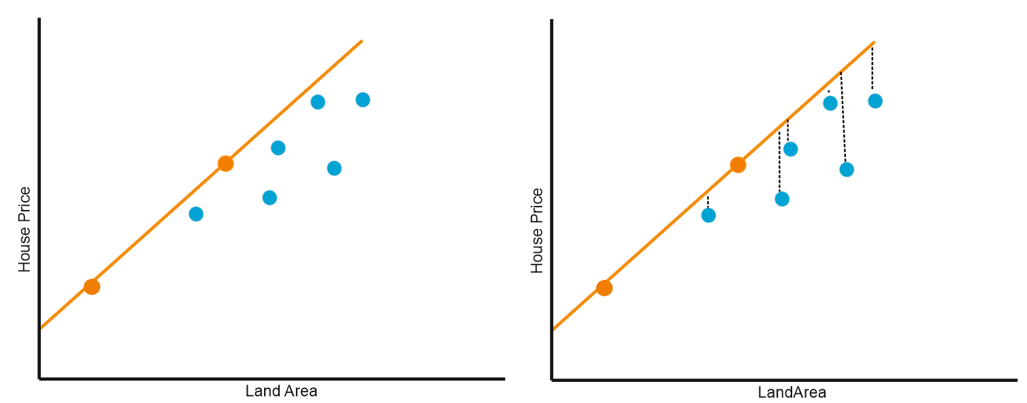
Figure 12 — Overfitting: trained on 2 orange points, fails on new blue points
Using only 2 training points (orange), a complex polynomial fits them perfectly. When tested on new data (blue dots), predictions are wildly wrong. The model has very low training error but very high test error.

16.3 Why Overfitting Happens
- Model is too complex for the available data.
- Training dataset is too small.
- Model trained for too many iterations without early stopping.
- No regularisation is applied.

16.4 Signs of Overfitting
Sign | Description
Training accuracy very high | Model fits every training point
Test accuracy much lower | Model fails on unseen data
Large train-test gap | Performance drops sharply outside training
Wiggly, complex decision boundary | Model follows noise, not trend
High sensitivity to input | Small change in input → large change in prediction

16.5 Problems Caused by Overfitting
- Model is useless in production — fails on any real-world data.
- Creates false confidence — high training accuracy is misleading.
- Wastes computational resources on an unreliable model.

17. Underfitting

17.1 Definition
Underfitting occurs when a model is too simple to capture the underlying patterns in the data. The model fails to learn from training data and performs poorly on both training and test data.

17.2 Causes
- Model is too simple (e.g., linear model for non-linear data).
- Too few features provided.
- Insufficient training iterations.
- Over-regularisation — penalty is so strong it prevents learning.
- Poor feature engineering.

17.3 Examples
- Fitting a straight line to data that follows a parabola.
- Using only 1 feature to predict house price when 10 features are available.
- Using a decision stump (depth-1 tree) on a complex classification problem.

17.4 Overfitting vs Underfitting — Full Comparison
Property | Overfitting | Underfitting
Training error | Very low | High
Test error | Very high | High
Train-test gap | Large | Small (both high)
Model complexity | Too high | Too low
Bias | Low | High
Variance | High | Low
Problem type | Memorises training data | Cannot learn patterns
Solution | Regularisation, more data | More complex model, more features
Other name | High-variance problem | High-bias problem

18. Why Regularization?

18.1 Overfitting Solution
When a model overfits, its parameters take on very large values that create a complex, wiggly prediction surface. Regularisation directly penalises these large values, forcing the model to become simpler and more general.

18.2 Complexity Reduction
By adding a penalty proportional to the size of parameters, regularisation limits the effective complexity of the model, even if a high-degree equation form is used. The model becomes less sensitive to individual data points.

18.3 Better Generalisation
A regularised model trades a small amount of training accuracy for substantially better test accuracy. Since the goal of ML is to perform well on real-world data — not just the training set — this trade-off is almost always worthwhile.

18.4 Balance Between Bias and Variance
Regularisation increases bias slightly (the model is less flexible) but significantly reduces variance (predictions are more consistent). The net effect is a more reliable model.
Key principle: A slightly biased but consistent model is almost always more useful than one that is sometimes exactly right but unpredictable on new data.

19. Regularization Techniques

19.1 Ridge Regression (L2 Regularization)

Definition
Ridge Regression adds the sum of the squared parameter values as a penalty to the cost function. This is the L2 norm penalty.

Cost Function with Ridge Penalty
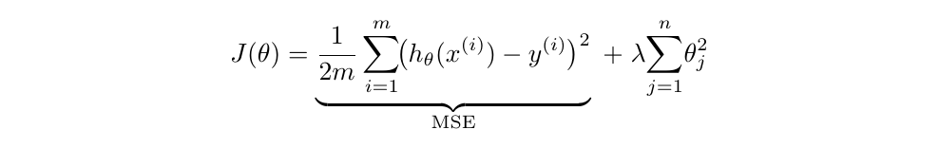
Symbol | Meaning
MSE | Mean Squared Error — original prediction cost
λ (lambda) | Regularisation strength hyperparameter — controls penalty size
Σθⱼ² | L2 penalty — sum of squared parameter values

How It Works
Ridge adds the squared magnitude of all coefficients to the loss. This forces the optimiser to keep all coefficients small. Crucially, Ridge never sets a coefficient exactly to zero — all features remain active in the model but with reduced influence.

Advantages
- Effectively prevents overfitting.
- Works well when all features genuinely contribute to the prediction.
- Handles multicollinearity — distributes weight evenly among correlated features.
- Mathematically smooth — has a unique, closed-form solution.

Disadvantages
- Cannot perform feature selection — all features remain in the model.
- Less interpretable with many features.
- Choosing the right λ requires cross-validation.

Use Cases
- When all features are relevant and should be kept.
- When features are highly correlated (multicollinearity).
- Regression problems with many features.

19.2 Lasso Regression (L1 Regularization)

Definition
Lasso Regression adds the sum of the absolute values of all parameters as a penalty. LASSO stands for Least Absolute Shrinkage and Selection Operator.

Cost Function with Lasso Penalty
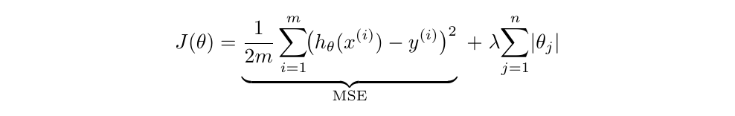
Symbol | Meaning
MSE | Mean Squared Error — original prediction cost
λ (lambda) | Regularisation strength hyperparameter
Σ|θⱼ| | L1 penalty — sum of absolute parameter values

How It Works
Lasso adds the absolute magnitude of coefficients to the loss. Unlike Ridge, Lasso can shrink some coefficients all the way to exactly zero, completely removing those features from the model.

Feature Selection Property
Setting coefficients to exactly zero is Lasso's most important advantage. This performs automatic feature selection: the model retains only the most predictive features and discards the rest.

Advantages
- Automatic feature selection — eliminates irrelevant features.
- Produces sparse, more interpretable models.
- Ideal when only a few features are truly predictive.
- Better for high-dimensional datasets with many irrelevant features.

Disadvantages
- With correlated features, Lasso arbitrarily picks one and discards the rest.
- Less effective when all features genuinely matter.
- Not mathematically smooth at zero — harder to optimise than Ridge.

Use Cases
- Feature selection in high-dimensional datasets.
- When you expect many irrelevant or redundant features.
- Building interpretable, sparse models.

20. Ridge vs Lasso Regression

Property | Ridge Regression (L2) | Lasso Regression (L1)
Penalty formula | λ Σθⱼ² (sum of squares) | λ Σ|θⱼ| (sum of absolutes)
Coefficient behaviour | Shrinks toward zero; never exactly zero | Can shrink to exactly zero
Feature selection | No — all features kept | Yes — irrelevant features removed
Model sparsity | Dense (all features active) | Sparse (few features active)
Interpretability | Harder with many features | Easier — fewer active terms
Multicollinearity | Handled well — distributes weight | Less stable — selects one feature
Mathematical smoothness | Smooth — unique closed-form solution | Not smooth at zero
Bayesian equivalent | Gaussian prior on parameters | Laplace prior on parameters
Best use case | All features are relevant | Only a few features are important
λ effect | Higher λ → more shrinkage | Higher λ → more features zeroed out

Rule of thumb: Use Ridge when you believe all features contribute. Use Lasso when you expect many irrelevant features and want automatic selection.

21. Quick Revision Notes

21.1 Key Definitions
Term | One-Line Definition
Gradient Descent | Iterative algorithm that minimises cost by moving parameters in the direction of the negative gradient
Cost Function J(θ) | Scalar that measures total prediction error across all training examples
Learning Rate α | Step size for each parameter update; must be tuned carefully
Hypothesis hθ(x) | The model's prediction function
Bias | Systematic error from wrong model assumptions; causes underfitting
Variance | Sensitivity to training data; causes overfitting
Overfitting | Model memorises training data; fails on new data (high variance)
Underfitting | Model too simple; fails on both training and test data (high bias)
Regularisation | Technique that penalises large parameters to prevent overfitting
Ridge (L2) | Regularisation via squared penalty; shrinks all coefficients
Lasso (L1) | Regularisation via absolute penalty; can zero out coefficients
Min-Max Normalisation | Scales features to [0, 1] for equal gradient contribution
Batch GD | Updates parameters using all m training examples per step
SGD | Updates parameters using one training example per step
Mini-Batch GD | Updates parameters using a small batch per step (standard in DL)

21.2 Important Formulas
Hypothesis (n features):
Cost Function:
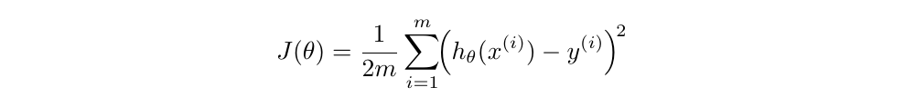
Gradient Descent Update Rule:

Expanded Update Rule:

Bias Formula:
Variance Formula:
Total Error Decomposition:

Ridge Cost:

Lasso Cost:

Min-Max Normalisation:

21.3 Key Concepts Summary
- Gradient Descent finds the cost minimum by iteratively moving in the direction of the negative gradient.
- Three GD variants differ only in how many examples drive each update: All (Batch) · One (SGD) · Mini-Batch.
- Bias = systematic error. Variance = sensitivity to training data.
- Underfitting = high bias + low variance. Overfitting = low bias + high variance.
- Regularisation reduces complexity by penalising large parameters — λ controls strength.
- Ridge keeps all features. Lasso performs automatic feature selection by zeroing irrelevant ones.
- Feature scaling (normalisation) is essential for Gradient Descent to converge efficiently.
- The ideal model has Low Bias + Low Variance — in practice we balance, not eliminate.

21.4 Comparison Quick Reference
Comparison | Option A | Option B
GD updates per epoch | Batch GD: 1 update | SGD: m updates
GD memory | Batch: entire dataset in RAM | SGD: 1 example only
GD convergence | Batch: smooth path | SGD: noisy/zigzag path
Fitting problem | Overfitting: low train, high test error | Underfitting: high both
Error source | High Bias → underfit | High Variance → overfit
Penalty type | L1 (Lasso): |θⱼ| | L2 (Ridge): θⱼ²
Feature selection | Ridge: No (all features kept) | Lasso: Yes (zeroes out features)

21.5 Exam Questions
- What is Gradient Descent? How does it minimise the cost function?
- What is the difference between Batch GD, SGD, and Mini-Batch GD?
- Define bias and variance. How do they relate to underfitting and overfitting?
- Explain the Bias-Variance Tradeoff. Why cannot both be zero simultaneously?
- What is regularisation? Why is it needed? How does it work?
- What is the difference between Ridge and Lasso Regression?
- Which regularisation technique performs feature selection, and why?
- How do you detect overfitting? How do you fix it?
- What happens when the learning rate α is too large? Too small?
- Why is Min-Max Normalisation important for Gradient Descent?

21.6 Viva Q&A
Viva Question | Short Answer
What does the cost function measure? | Total prediction error across all m training examples.
What happens if α is too large? | GD overshoots the minimum — cost diverges instead of decreasing.
What is a batch in Mini-Batch GD? | A small subset (e.g., 32–256 examples) used for one parameter update.
Why does SGD have noisy convergence? | Each update uses only one example, so each gradient estimate is imprecise.
What does high bias indicate? | The model is too simple — it underfits and cannot capture the real pattern.
What does high variance indicate? | The model is too complex — it overfits and memorises training data.
How does Lasso select features? | The L1 penalty can shrink coefficients to exactly zero, removing those features.
Why is Ridge better for correlated features? | Ridge distributes weight among correlated features; Lasso arbitrarily picks one.
What is the main goal of regularisation? | Reduce model complexity and prevent overfitting by penalising large coefficients.
What is the ideal ML model goal? | Low Bias + Low Variance — accurate average predictions and consistent across datasets.
When to choose Ridge vs Lasso? | Ridge: all features matter. Lasso: only a few features are truly important.
What does λ control in regularisation? | Regularisation strength. Higher λ = stronger penalty = simpler model.
What is Min-Max normalisation for? | Scale features to [0,1] so all features contribute equally to the gradient.
What is online learning in SGD? | SGD can continuously learn from newly arriving data without restarting training.

End of Study Note — Machine Learning Part 3
Good Luck with Your Exams!

